**St. Leo’s School**

**233 Memorial Drive, Brantford, Ontario N3R 5T2 Tel. (519) 759-3314**

**Website:** [**www.bleo.bhncdsb.ca**](http://www.bleo.bhncdsb.ca) **Twitter: www.twitter.com/@stleocatholic**

**Principal: Mrs. J. McLaren Gibbons**

September 20th, 2018

***PLEASE complete permission form and consent form and return by Tuesday, October 2nd, 2018***

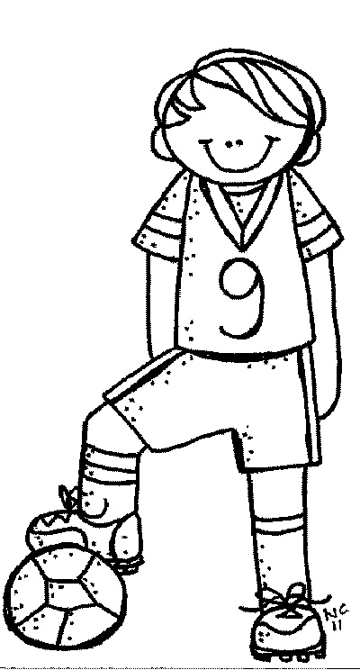Dear Parents of AAA Intermediate Co-Ed Soccer Team members,

Your son/daughter will be competing in the Board-wide AAA Division Co-Ed soccer tournament on **Thursday, October 4th, 2018** at John Wright Soccer Fields in Brantford. The rain date is Wednesday, October 10th , 2018.

Students will be transported to and from the tournament by bus, at no cost to families. Buses will pick up the students from the school no later than 8:45 am (exact pick up time will be provided to students before the tournament). Students will return once the team has either been eliminated or have won the championship game. Because an exact return time cannot be determined, please indicate, below, your approval for your child’s return home following the tournament.

Students will be able to purchase food at a concession stand however, it is recommended that students still bring a healthy lunch and healthy snacks. I am also encouraging students to bring water.

Please note that parents are welcome to cheer on the team but school-aged children who are NOT participating may not attend.

Thank you for your support,

Mme Poulimenos

French Immersion Kindergarten Teacher

Intermediate Co-Ed Soccer Coach

**PLEASE SELECT ONE OPTION FOR ALL DAYS:**

□ My son/daughter has permission to walk home/take the bus as usual *if they*

*return before 3:05 dismissal.*

My son/daughter has permission to walk home *even if after dismissal time.*

□ Please call home when the team returns. I will provide direction at that time.

□ I will be at the tournament and will drive my child home after the tournament.

□ I give permission for my child to ride home after the tournament with

_______________________________ (please print name clearly)